ACP Policy Set ToBlock

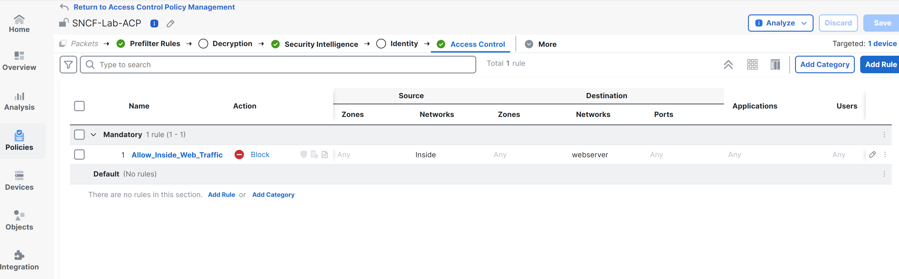

Prefilter Policy set to FastPath

